**RING WIZARDRY**

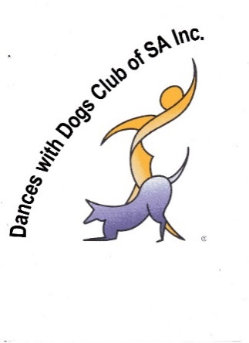**Dances With Dogs Club of S.A. Inc.**

**TRAINING CLASS ENROLMENT FORM 2025**

Handler:

Other Handlers:

Mobile:

Email:

Do **YOU** have a physical limitation we should allow for in class? □ Y □ N

Please describe?

Emergency Contact

Name:Mobile:

**Dog’s Name**:Breed:

Age: …………. mths/yrsSex: M / F Desexed: *Yes ❑ No ❑*

Does **your dog** have any physical limitations **or**medical conditions? *Yes* ❑  *No*❑

Does your dog have a food allergy? □ Y □ N

Please describe the condition(s):

List 3 Goals you would like to accomplish while in class

Any comments you think will help with training or that you feel we should know about?

Please sign reverse side of form. Return to Elaine Kennedy superzoedog@gmail.com

***AGREEMENT FROM CLIENTS GIVEN TO THE INSTRUCTOR***

Digital images and/or video footage of your dog and occasionally of yourself and anyone accompanying you may be taken. This material may be used by the Instructor or the Dances with Dogs Club of SA for educational, promotional or training purposes. You will not be identified by name if this material is used. There will be no reimbursement of any kind for the use of this material.

**By signing this form, you agree to digital images and/or video footage being used as outlined above.**

*Signature of handler/s: Date ……………………*

*Name of handler/s:*

***If Junior Handler (*12 TO 18*)***

*Signature of authorised guardian: Date …………………….*

*Name of authorised guardian:*

***WAIVER FROM CLIENTS GIVEN TO THE INSTRUCTOR:***

**The Dances with Dog Club of SA aims to provide a safe environment for training, and to utilise minimal risk procedures during training. However, there is always an element of risk involved. As such, all clients are required to sign the following waiver before they can begin training.**

“I understand that this training program is not without risk to me, my dog, or any other human or animal. Some dogs to which exposure may occur may be difficult to control and may be the cause of injury even when handled with the utmost care and caution.

I hereby waive and release the Instructor and any assistants from any and all liability of any nature for any injury or damage which I, my dog, or any other human or animal may suffer, including specifically, but without limitation, any injury or damage resulting from the actions of any dog, including my own.

I expressly assume the responsibility for my own dog and the risk of any such damage or injury while in attendance at any training session or other function conducted by the Instructor, or whilst on the training grounds, my own property, or other such property as training sessions may occur at from time to time.

I assume all responsibility resulting from the actions of my dog with respect to injury sustained by any other person or dog as a result of the actions of my dog.”

*Signature of handler/s: Date……………………….*

*Name of handler/s:*

***If Junior Handler (*12 TO 18*)***

*Signature of authorised guardian: Date ……………………..*

*Name of authorised `guardian:*