Further instructions for competitors
Firstly, we hope you and your dogs/s have lots of fun.
Please read the following information carefully and let an official know if you have any queries.
Ring Information
The rings are numbered 1-3 and will also be identified by colour. Ring 1 Red, Ring 2 Blue, Ring 3 Yellow. Judges will not be moving from one ring to another. A catalogue will be provided outside the ring, so please do not disturb the stewards by reading theirs.
Flags will indicate the status of each ring.
- Red is being set up.
- Yellow course is being walked
- Green course is running
Walking times will ideally be no more than 10 minutes, but this is up to the judge who may choose to vary this time. Each ring will have its own set of equipment, so ideally do not move it from one ring to another. Equipment and rings will be packed up prior to presentations on the Monday
Judge’s briefing
There will be one judge’s briefing in each ring at commencement of the day and further course information will be provided outside the ring with SCTs and any other instructions necessary. However, it is up to the judge to decide if they want to give a briefing prior to commencement of the class.
Entry and exit
The rings will have an exit and entry shute. Ideally we want three dogs lined up in the entry shute at any time while course are running. If your dog requires extra space, please let the assembly steward know. To keep the rings moving you will be requested to enter as the previous dog is finishing (depending on the judge’s instructions). Please don’t remove your dog’s lead until the previous dog is on lead. When you have finished your run your lead will be in the bucket at the exit shute. Please ensure your dog is on lead prior to leaving the ring.
Leads
Leads must be removed and handed to the steward. But you may carry a smaller lead in your pocket, so long as it is concealed and is only produced when the round is completed. If it drops on the ground during your run, you will be DQed.

Treats and toys
Treats and toys may be left in the buckets at the entry and exit shutes. These will be positioned at least 5m from the ring. Please take care in approaching the buckets and give other handlers and their dogs space.
Competitor Numbers
You will see a coloured sticker on your number. This identifies the ring we would like you to assist in, where possible. Please be prepared to assist in re-setting heights where possible.
You will get two numbers in your package one is for your dog’s lead. Please connect this using a zip tie (provided on tables outside the clubhouse), making sure you cut off the end, so it is not a danger to your dog’s eyes. This number will be taken by the lead steward to identify the dog running to reduce the chance of errors. You will keep the same number for all three days.
General Behaviour
Keep in mind there are many competitors and there is limited space available. When walking your dog or to or from the rings please keep your dog on a short lead and do not let your dog approach other dogs. Do not walk close to tents where dogs are tethered.
We want the competition to be fun and pleasant for all, so please be polite to everyone, in particular the judges and volunteers. The stewards are in charge of who enters the ring. To keep things moving, dogs may be run out of order. When requesting a change of position, keep in mind others who are before you may also have ring clashes. If you are running in multiple rings, please let the assembly steward know prior to the class commencing.
Problems
If you have any problems each ring will have a walky talky for officials to direct your query to the correct person.

Sponsor Offers
 are offering attendees at the championship the chance to win a years supply of 4CYTE For Dogs. Details on how to enter will be displayed on posters outside the clubhouse.
are offering competitors a discount of 20% on regular-priced products between 7th June and 5th July 2025 (see information below).

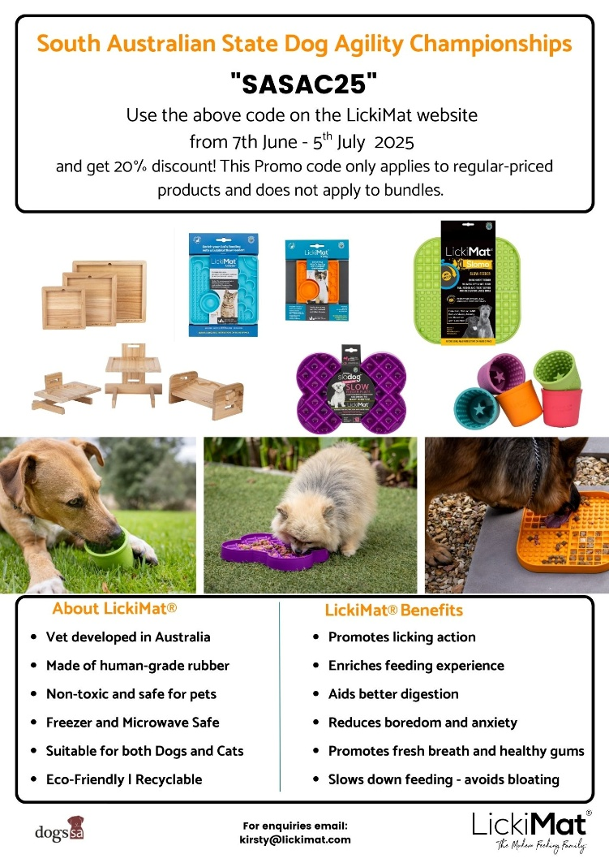

24 hour Veterinary Services
We are aware that there are many interstate competitors. Below are the details of several 24 hr vets. We hope this won’t be required.
SASH Small Animal Specialist Hospital
(08) 8125 7132
infosa@sashvets.com
99 Rundle Street, Kent Town
The Austin Emergency Vet
19-21 William Street
Mile End, 5031 SA
08 8166 3828
Greencross Vet Centre
102-104 Magill Road, Norwood, SA, 5067
Emergency Open 24/7
GP services: Open Mon - Fri 8am - 6pm , Sat 8am - 1pm
Referral Service: Open Mon-Fri 8am - 5pm
08 8132 0533

