**DOGS WEST STATE OBEDIENCE & RALLY TRIAL**

SATURDAY 30th NOVEMBER 2024

*The DogsWest working party like to thank you for entering and your support.*

*We wish you all the best of luck.*

# JUDGES

MS DEB HYDE UD, CD & CCD

MR FRANK WEARING CDX

DR. DI WEBB RE & RA

MRS CHERYL BEDGGOOD RM & RN



**PRIZES (Qualifying scores only)**

## OBEDIENCE & RALLY

*1st in all classes*

Trophy, Sash, Dog Biscuits donated by Eukanuba, Prize

*2nd in all classes*

Sash, Dog Biscuits donated by Eukanuba, Prize

*3rd in all classes*

Sash, Dog Biscuits donated by Eukanuba, Prize

We like to thank the following clubs, businesses and individuals who donated towards the 2024 Dogs West State Obedience & Rally Trial

* Eukanuba Australia
* German Shepherd Dog Association of WA
* Midland Dog Training Club
* Northern Suburbs Training & Obedience Dog Club
* Orlando Dos Santos & Results Dog Training
* Perth Training & Obedience Dog Club
* Southern River Agility & Obedience Dog Club
* Susan Briggs
* Maja Pitts

**Thank you for your contribution!**









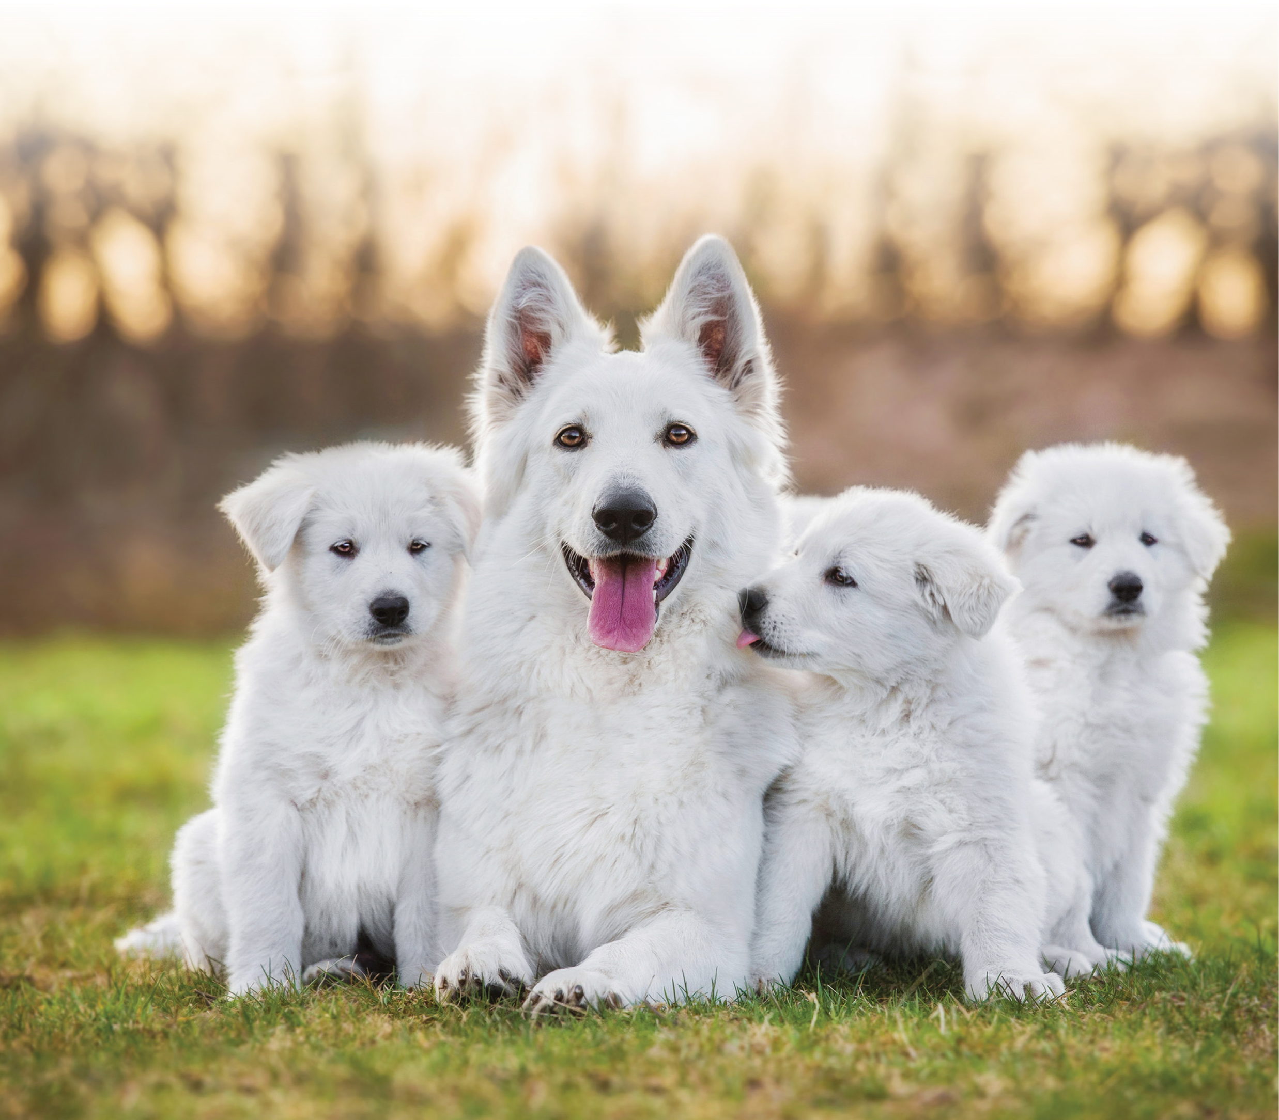

/7 online ordering

24

FREE shipping on all orders*

Exclusive pricing and promotions

FREE Puppy Packs with any order*

**EUKANUBA**

**™**

**PROFESSIONAL CLUB BENEFITS**

**To join the Eukanuba™**

**Professional Club scan**

**the QR code or visit:**

**eukanuba.com/au**

Join Our

**Family**



**TEAMS EVENT FOR STATE OBEDIENCE & RALLY 2024**

**OBEDIENCE**

1/ THREE DOG TEAM

* MUST BE MADE UP OF THREE DIFFERENT DOGS

2/ ONLY 1 BEST SCORE CAN BE USED FOR EACH DOG

* FOR EXAMPLE: DOG A ENTERED OPEN & UD AND RECEIVED 185 POINTS IN OPEN AND 195 POINTS IN UD. ONLY ONE (1) OF THESE CAN BE USED TOWARDS THE TOTAL TEAMS SCORE

3/ ALL CLASSES CAN BE USED INCLUDING CCD

* HOWEVER – CCD IS WORTH 100 POINTS AT BEST, ALL OTHER CLASSES ARE WORTH 200 AT BEST

4/ ALL SCORES WILL BE COUNTED

* HOWEVER, QUALIFYING SCORES TAKE PRECEDENCE OVER NON-QUALIFYING SCORES.

**RALLY**

1/ THREE DOG TEAM

* MUST BE MADE UP OF THREE DIFFERENT DOGS

2/ ONLY 1 BEST SCORE CAN BE USED FOR EACH DOG

* FOR EXAMPLE: DOG A ENTERED ADVANCED & EXCELLENT RALLY AND RECEIVED 95 POINTS IN ADVANCED AND 90 POINTS IN EXCELLENT RALLY ONLY ONE (1) OF THESE CAN BE USED TOWARDS THE TOTAL TEAMS SCORE

3/ FASTEST TIME WILL SECURE A PLACE IF A TIE OCCURS

If a dog is competing in more than one class then that dog can go in more than one team, however they must use a different class, each team MUST be made up of three different dogs.

Teams enter on the day using their catalogue numbers and recording their team name, entry is free and team entry must be lodged at least ½ hour before the start of the competition.

**COMPETITION NAME**

Prize donated for the best team name

**WINNING TEAM OBEDIENCE & RALLY**

Prize for all three winners



***Chief Steward: Orlando Dos Santos***

***First Aid officer: Maja Pitts***