
Southern River Agility and Obedience Dog Club Presents

Double Novice Trial
Trinity College , 2 Trinity Way, East Perth
Sunday 21 June 2026
9am Novice Vehicles – Ben Allen
9am Novice Interiors – Tracey O’Neill
Target Odour – CLOVE
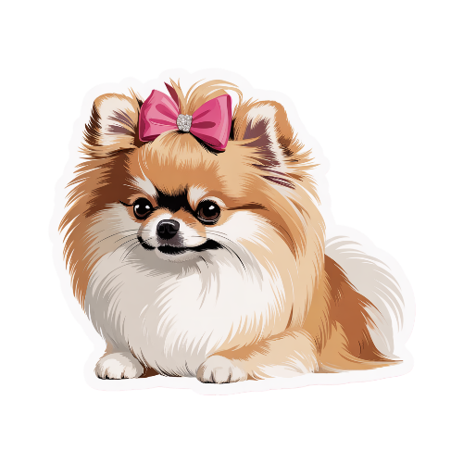
Competitor Briefing

8:45am for both classes.
Presentations at conclusion of both classes. Electronic qualification cards will be used. Rosettes for 1st, 2nd and 3rd. Judges prize and qualifier ribbons

IMPORTANT A reminder that competitors cannot discuss any details of their search. Seemingly innocuous comments like 'She search really well' 'We almost timed out' 'He was so distracted' are not permitted according to rule 13.12 and can result in a disqualification. 13.11 Handlers may only indicate their search outcome with a ‘yes’ or ‘no’ (thumbs up or thumbs down) after leaving the search area. 13.12 Handlers must not divulge any information about the search, the location of the hide, or details of their search until all teams have completed the particular Class/Element. *** Breach of this Rule will result in Disqualification from the trial and all results achieved at the trial will be voided.
Competitor Parking & Trial Details
Please enter from Trinity Ave and park within the yellow area on the map. Please do not walk your dogs in the Red areas including on the cricket pitch. No dogs at the registration desk, briefings or presentations please. The Interior Search is near the Gazebo and Vehicles will be in the undercover parking near the pool. The Registration desk will be located under the gazebo. Please ensure you have checked in prior to the competitor briefings. TOILETS – are located to the left of briefing.
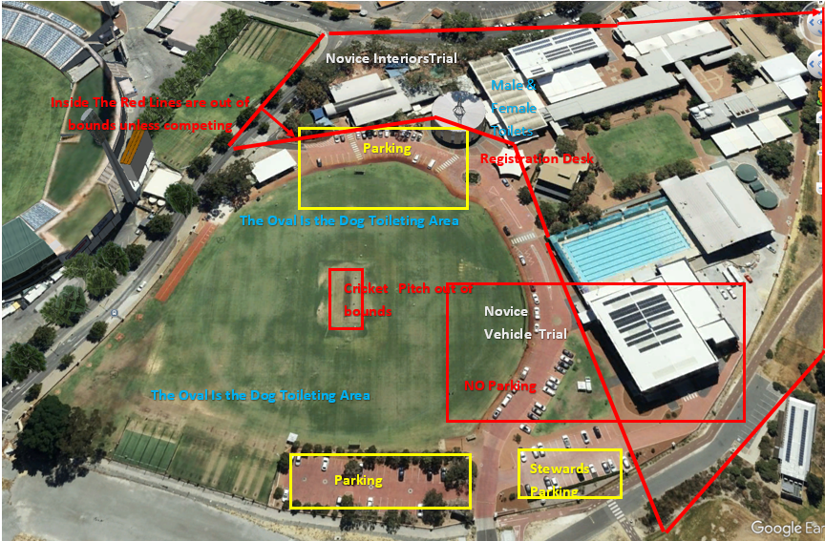

Double Novice - Interior Novice (SWIN) |  |  | Judge: Tracey O'Neil
Cat# | Dog Name | Handler | Breed
1 | Pawsforever Nugget Stella | Gerda Peerdeman | Labrador Retriever
2 | Mouse | Anastasia Korotkova | Associate Register
3 | NEUT. CH. Russkimir Smoke N Wishes | Anne Flint | Borzoi
4 | Dawnsio Sonic Boom | Samantha Maybury | Cocker Spaniel
5 | Gaston | Erin Mias | Associate Register
6 | Noblestarzz Midnight Million | Emma Scott | Border Collie
7 | Pudelian Cocobean | Paquita Galan-Dwyer | Poodle (Miniature)
8 | Lysthom Cuba | Kylie Foster | Labrador Retriever
9 | Jamzaaba Quintessential (AI) | Dawn Buchanan | Rottweiler
10 | Missy | B C Rositano | Associate Register
11 | Ironbark Winsome Willow | Tara Glover | Golden Retriever
12 | Giday Tru Blu Banjo | Susan Briggs | Poodle (Standard)
13 | Cathgarry I Feel Like Dancing | Joan Tobin | Collie (Rough)
14 | Netherdee Shadows Minnimee (AI) | Ann Graham | Cocker Spaniel
15 | Bohemije Leading White Star Jr | Dana Doupovec | Schnauzer (Miniature)
16 | Vonkery Chances Are | Louise Wulfz | Affenpinscher
17 | Baydrift Mr Mack | Nicole Wilson | Labrador Retriever
18 | Lone Star Narrah | Tracey Teague | Sporting Register
19 | Bonsue High Court Justice (AI) | Sarah Oliver | Boxer
20 | Goldmaid Pippa (AI) | Birgitta Krieger | Welsh Springer Spaniel
21 | Lynette | Sean van Elden | Associate Register
22 | Xstellaration | Helen Stathy | Associate Register
23 | Kobnko Wired West | Jillian McAullay | German Wirehaired Pointer
24 | Mavis | Anne Humphrey | Associate Register
25 | Love | Indah | Associate Register
26 | Jetboom Rhodanthe Rose | Julie Peeler | Boxer
27 | Ghostwind Greta Garbow (AI) | Hannah Cresswell | Weimaraner
28 | Lola | Anita Adams | Associate Register
29 | Redgully Denoz | Victoria nemeth | Sporting Register
30 | Summer | Amy Lawrence | Associate Register
31 | Minipatas Pluto My Pal | Jerline Chen | Poodle (Miniature)
32 | Jupiter | Claire Ha | Associate Register
33 | CH. Brightshaw Star Attraction (AI) | Holly Brighton | Golden Retriever
34 | Borderton Whats New Pussycat | Wayne Shoobridge | Australian Shepherd
35 | Daintyfield Beckham At Wharf | Briony Hearman | Field Spaniel
36 | Catwg Lightning Bolt | Jasmin Livsey | Labrador Retriever
37 | Monty | Zoe Crowest | Associate Register
38 | CH. Mossrose Abracadabra | corinne ohehir | Border Terrier
39 | Wentlooge Meadow Of Millthorpe | Sonja Duljas | English Springer Spaniel

Double Novice - Vehicles Novice (SWVN) |  |  | Judge: Ben Allen
Cat# | Dog Name | Handler | Breed
40 | Mavis | Anne Humphrey | Associate Register
41 | Love | Indah | Associate Register
42 | Jetboom Rhodanthe Rose | Julie Peeler | Boxer
43 | Ghostwind Greta Garbow (AI) | Hannah Cresswell | Weimaraner
44 | Redgully Denoz | Victoria nemeth | Sporting Register
45 | Summer | Amy Lawrence | Associate Register
46 | Minipatas Pluto My Pal | Jerline Chen | Poodle (Miniature)
47 | Jupiter | Claire Ha | Associate Register
48 | Daintyfield Beckham At Wharf | Briony Hearman | Field Spaniel
49 | Frank | Kim McCleary | Associate Register
50 | Bunjiblu Our Sweet Ilsa | Kathrina Oakland | Australian Cattle Dog
51 | Candycolour Tickle Belles (AI) | Leesa Harrison | Cocker Spaniel
52 | CH. Bromhund Show Off (AI) | Christine Weetman | Weimaraner
53 | Odin | Brooke Coniglio | Associate Register
54 | Triseter Mopsi Yuletide | Heidi Ansell | Pug
55 | T.CH. Vonroth Reno | Katelyn Holdsworth | Dobermann
56 | Ptolomy Hot Shoe Shuffle | Jennifer Levy | Nova Scotia Duck Tolling Retriever
57 | Pantathean Oceanus | Brianna Rositano | German Shepherd Dog
58 | Pawsforever Nugget Stella | Gerda Peerdeman | Labrador Retriever
59 | NEUT. CH. Russkimir Smoke N Wishes | Anne Flint | Borzoi
60 | Dawnsio Sonic Boom | Samantha Maybury | Cocker Spaniel
61 | Gaston | Erin Mias | Associate Register
62 | Noblestarzz Midnight Million | Emma Scott | Border Collie
63 | Pudelian Cocobean | Paquita Galan-Dwyer | Poodle (Miniature)
64 | Lysthom Cuba | Kylie Foster | Labrador Retriever
65 | Jamzaaba Quintessential (AI) | Dawn Buchanan | Rottweiler
66 | Missy | Vlad | Associate Register
67 | Ironbark Winsome Willow | Tara Glover | Golden Retriever
68 | Giday Tru Blu Banjo | Susan Briggs | Poodle (Standard)
69 | Cathgarry I Feel Like Dancing | Joan Tobin | Collie (Rough)
70 | Netherdee Shadows Minnimee (AI) | Ann Graham | Cocker Spaniel
71 | Bohemije Leading White Star Jr | Dana Doupovec | Schnauzer (Miniature)
72 | Vonkery Chances Are | Louise Wulfz | Affenpinscher
73 | Baydrift Mr Mack | Nicole Wilson | Labrador Retriever
74 | Lone Star Narrah | Tracey Teague | Sporting Register
75 | Bonsue High Court Justice (AI) | Sarah Oliver | Boxer
76 | Goldmaid Pippa (AI) | Birgitta Krieger | Welsh Springer Spaniel
77 | Robmond Part Time Love | Sally Thomas | Cocker Spaniel
78 | Lynette | Sean van Elden | Associate Register
79 | Xstellaration | Helen Stathy | Associate Register
80 | Kobnko Wired West | Jillian McAullay | German Wirehaired Pointer

