GAWLER DOG TRAINING CLUB INC

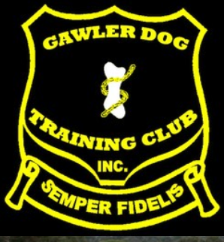

SCENT WORK TRIAL

TUESDAY 5th MAY 2026

APPROVED SCENT WORK TRIAL SCHEDULE
Not for publication

ENTRIES CLOSE: Monday 28TH April 2026
Affiliate: GAWLER DOG TRAINING CLUB INC
Type of Exhibition: Scent Work trial
Day, Date and Time: 7pm Tuesday 5th May 2026
Venue: CLUB GROUNDS, ELLIOTT GOODGER MEMORIAL PARK, WILLASTON

Start time/day | Class | Element | Judge | Entry limit
7pm Tuesday | Advanced | Interior | Fay Mullan | 35

The Club reserves the right to appoint a reserve judge or a replacement if necessary.
TARGET ODOURS: Advanced: Birch and Clove
TRIAL MANAGER/SECRETARY: Lynne Stapylton
SACA REPRESENTATIVE: Casey Ryan
CHECK-IN AND VETTING: 6:15pm to 6:30pm. Bitches without proof of de-sexing to be in vetting area. All dogs must pass through checkpoint by close of vetting.
JUDGES BRIEFING: Immediately after the close of vetting.
ENTRY FEE: $15 per entry.
CATALOGUE: Available on the Scent Work SA Facebook page 1 day prior to the trial.
ENTRY LIMITS: Entry limit as specified above. Should balloting be required this will occur on Tuesday 29th April 2026.
ENTRY AMENDMENTS: Competitors must only enter those elements that they are eligible to enter at time of entry. After close of entries no further entries will be received. Any upgrade requests after close must be made prior to the conducting of the ballot. Once the ballot is conducted no further amendments to entries will be permitted.
JUDGING ORDER: As above. Judging may commence with judges and stewards’ dogs followed by the remaining competitors.
SASHES AND PRIZES: Ribbons to all qualifiers. Prizes as outlined in the catalogue.
Competitors should be aware that the Elliot Goodger Memorial Park is a public reserve and members of the public and their dogs may be present at the trial venue, and that the car parking area is a shared space with other organisations (BMX, Football, Netball Clubs) based at the Park.
ENTRIES: Online entries and payments via Top Dog Events (https://www.topdogevents.com.au) Paper entries to the Trial Secretary, 66 Eagles Nest Drive Bibaringa SA 5118. Paper entries must be submitted on the official scent work entry form. Please contact trial secretary for direct deposit details if intending to submit a paper entry. Email entries not accepted due to online being available.
CATERING: Not available.
Dogs SA Extreme/Hot Weather Rules:
The Dogs SA Extreme/Hot Weather Rules will be applied. In accordance with those rules, the trial or a class/es thereof, may be postponed, canceled or delayed. In the event the trial or a class/es thereof is canceled, there will be no refund of entry fees where that entry is for a class/es or trial that is canceled. Exhibitors should note that the Dogs SA Rules prevail and should therefore familiarise themselves with the Dogs SA Extreme/Hot Weather policy.
QUERIES: lynne.stap@gmail.com

(ends)

WELCOME
Thank you for your entries and also to all the judges and stewards for assisting with the running of this trial. Also thank you to those that have helped with the planning and organization of this trial and with set-up on the day.
Please remember that everyone involved in this trial is a volunteer so please be respectful of all those giving up their time to provide you and your dogs with this opportunity.

SEARCH AREA AND TRIAL PRECINCT
All competitors should ensure that they are familiar with the areas indicated in the map that can be accessed on the day of the trial and those areas that should not be accessed unless under direction of a trial official.
Please remember that the Elliot Goodger Memorial Park is a public reserve and members of the public and their dogs may be present at the trial venue, and that the car park is a shared space with other organisations (BMX, Football, Netball clubs) based at the Park.
Competitors should not, unless directed by a trial official, go to the front of the Dog Club clubhouse, nor onto the grass training area. Competitors should not go past the start of the netball courts nor on to the BMX track area.
Do not park in the row of car parks immediately behind the Clubhouse – this area will be the marshalling area.
Please follow the directions of officials carefully.

TOILETS
Competitors will access the toilets along the side of the clubhouse – go along the walkway.

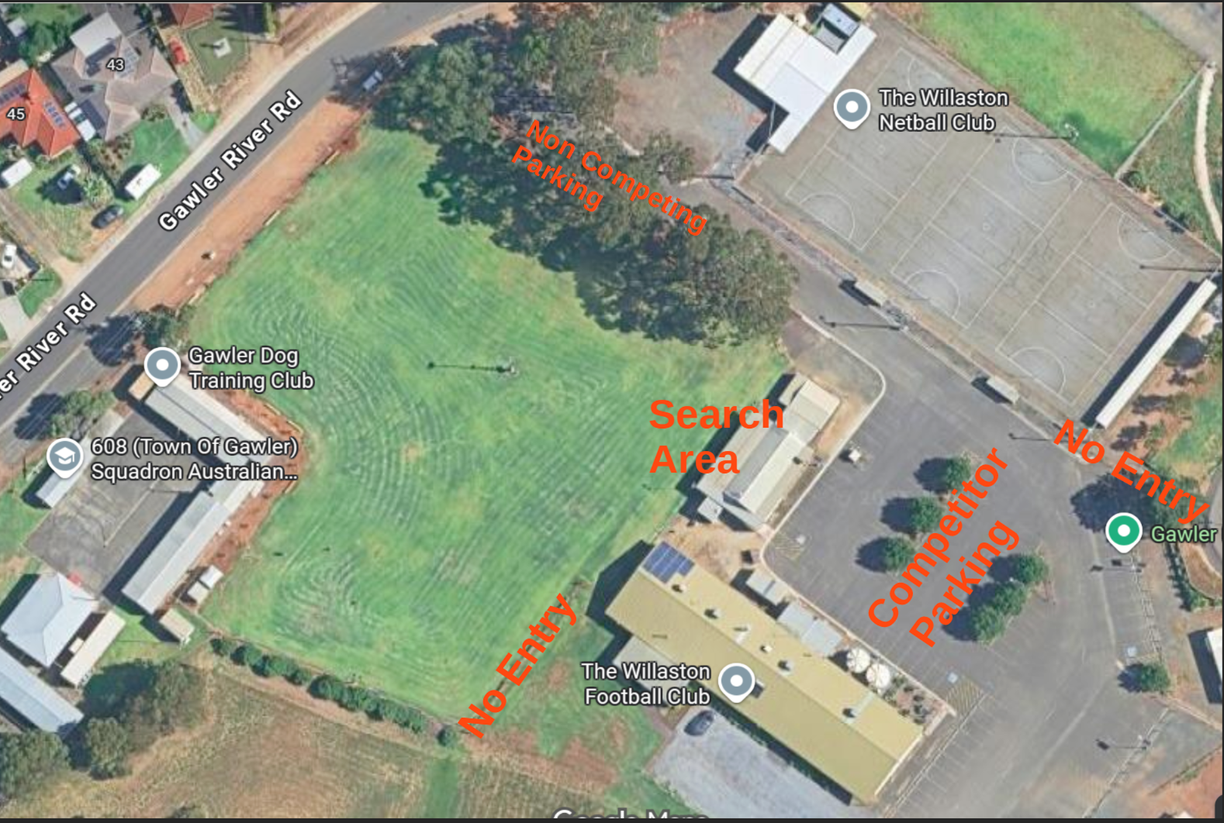

COMPETITOR CHECK-IN, VETTING AND BRIEFING

Competitor check-in,vetting and briefing will occur in the competitor parking area unless communicated otherwise.
Check-in: 6.15 to 6.45pm
Briefings will be held at the conclusion of vetting. No dogs to be present at the briefing.

COMPETITOR NUMBERS
Bring your own, and just in case pens and cards will be provided at check-in.

RUNNING OF SEARCHES
Competitors will search according to the catalogue order as listed unless otherwise communicated at the briefing. Competitors may need to self marshal. Trial officials may complete their searches first before the remaining competitors begin to be called. Competitors should ensure they are ready when it is their turn to search.
Any competitor absent after 3 calls from the judges steward without prior approval of the judge and trial manager will be marked absent and not be allowed to participate in the search.

STEWARDS AND HELPERS
Thank you to the following people who have volunteered their time to help with the running of the trial.
Check-In and Vetting – Sharon Mewett
Timer – Carmel Nottle
Judges Steward – Sandra Kramer
Marshalling – Barb Joseph
Cards – Lynne Stapylton

PRESENTATION, PRIZES AND AWARDS
Presentations will be conducted at the conclusion of judging. There is to be no dogs present at presentation.

COMPETITOR RULE REMINDERS
While competitors should always read the rules for the sport and be aware of their responsibilities as an exhibitor, they are strongly encouraged to refresh themselves on the following rules and codes:
ANKC RULES OF THE CONDUCT OF SCENT WORK TRIALS
9.0 Organisation of the trial
9.5 Dog attire
12 Photography and recording devices
12.1 – 12.7
Posting on Facebook and other social media platforms is not considered ‘personal use’ regardless of the privacy settings of the group or page being posted to.
13 Handlers
13.3, 13.4-13.6, 13.11-13.13
Any competitor arriving at the grounds with target odours other than a person engaged in the administration of the trial should not arrive before the start of the specified vetting time and should immediately contact the trial manager for storage of any odour for the duration of the trial.
SACA Rules Code of Conduct for Exhibitors
PART XV Codes
C. Code of Conduct for Exhibitors
Dogs SA Exhibitors Code of Conduct

Scent Work -Advanced Interior - Interior Advanced (SWIA) - Judge: Fay Mullan
Cat# | Dog | Handler
1 | Twiggy | Mirlanda Fischer
2 | Parkridge Polly Borrowdale | Melissa Borrowdale
3 | Yaxeka Let It Go | Denise Adams
4 | Giltedge Hans Solo | Lynne Stapylton
5 | Lola | Jo Webb
6 | Comeby Team Bosnich | Alex Stapledon
7 | Pawtrax Siirinhannus Gunnar | Jordan Anderson
8 | Leema Eternity | Tegan Whalan
9 | Koolywong Too Hot To Handle | Toni Gardiner
10 | Jango | Kathryn Wiltshire
11 | Morehill Scarlett In Red | Karen Moralee
12 | Thistledust Illuminate | Rebecca Knapp
13 | Mistypoint Sharp Dressed Man | Tracie Edwards
14 | Dunwurkn Its All About Me | Roger Green
15 | Wilderblu Abby | Anne-Marie Hartman
16 | Coniki Elementary Mdear Watson (AI) | Teresa Shanahan
17 | Meeka | Bronwyn Korendyk
18 | Belgenbeau Taliondal Princess | Tania Adams
19 | Rozate Hugs N Chocy Frogs | Christina Dalla Valle
20 | Laugharne Foxy Lady | Allison Warr
21 | Guilcroft Waltz With Matilda | Tammy McClelland
22 | Thistledust Black Patch | Robyn Coburn
23 | Recoil Weapon Of Choice | Tegan Larrett
24 | Rivanova Vixens Virtues | Jo Shirlock
25 | Heiderst Journey To The Stars | Yvonne Nieuwenhoven
26 | Wattswires Im A Keeper | Linda Robinson
27 | Mistypoint Watch Your Tongue | Nicole Elkins
28 | Indy | Julie Pawlowski
29 | Wilderblu Double Dare | Sharon Mewett
30 | Glenmave Rythm Of My Heart | Jacquie Dealtry

(ends)

