
Master ‘Rescue’ Scent Work Trial
Thursday 30th April 2026
Public Safety Training and Response Group,
2257 Ipswich Rd (entry from Jutland St-see map below), Oxley, QLD

Check-in Time: 5.30-5.45pm
COMPETITOR BRIEFING 5.50pm.
Starting at 6pm: Master Interior – Ms Natalie Kirkwood
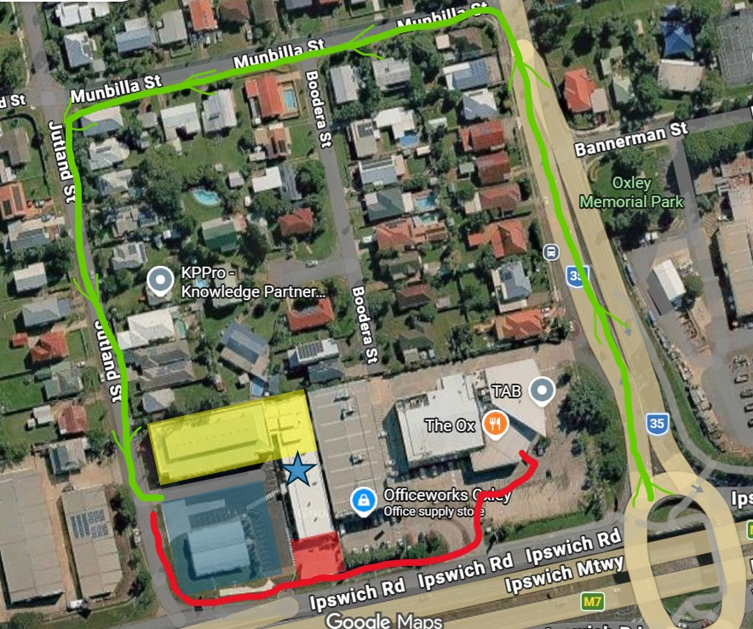
Master Vehicle – Ms Tracey Bruhn

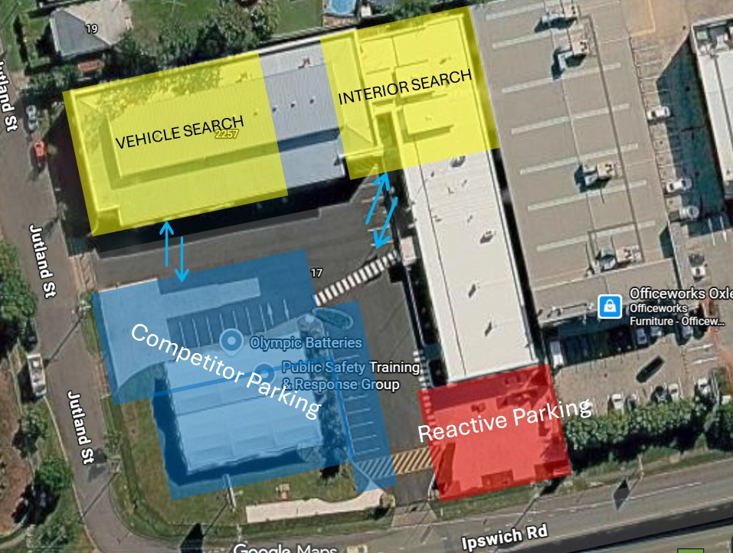
Please follow the Car-Park Stewards directions.
Interior and Vehicles will run concurrently.
Please see Catalogue for running order. Interiors take priority.
Advocate for your Dog at the Entry/Exit.

DOG TOILETING: Please try to Toilet your Dog on the grass verge outside the premises.
Trial Precincts:
Interior and Vehicles Search Areas - YELLOW
Please collect your competitor number. Check-in Table will be outside Reception.
Please ensure entire Bitches (as per TOP DOG Registration) are vetted by a Club Member.
If you wish to withdraw from a class, please inform the Assembly Steward.
PARKING: Please be considerate when Parking. Everyone should fit - BLUE
Reactive Dog Parking as indicated on map – RED
Stewards and Judges Parking - Green
Any Dog not competing must remain crated or in their vehicle, unless on a lead whilst toileted.

All Dog waste and Rubbish must be collected and taken with you.

HUMAN TOILETS: Located inside The OX, a short walk (3 min) past Officeworks.
As indicated by the RED LINE
Toilets inside the facility will only be available after searching is complete.

AWARDS/PRESENTATION: Q Ribbons are available. Q Cards will be available within a couple of days to download from Top Dog. Ribbon and Prize for First, Second and Third Placings. Title Ribbons available also!!

CATERING: No Catering for this Trial.
Local Food Outlets nearby: The OX (Oxley Hotel) just past Officeworks, do online ordering with DoorDash and click and collect.
McDonalds (24hr) and Subway (until 9pm)-both behind Bunnings.

GENERAL: Please check your details are correct in the catalogue. Advise the Trial Secretary as soon as possible if changes are required.
Please be mindful of the nearby residents and other competitors. Excessive barking will not be tolerated. Competitors will be responsible for cleaning up after their dog/s and themselves.
Rudeness and aggressive behaviour towards another person will not be tolerated and you may be asked to leave the premises.

A HUGE Thank you to the Rescue Group for the use of their Wonderful facilities!!
Thank you for your Support and Entries! Have a Great Sniff!!




INTERIORS – Natalie Kirkwood
No |  | Handler | Dogs Name | Dogs Breed
1 |  | Tracey Bruhn | Andleerott Fryday | Rottweiler
2 |  | Tess McGilp | Keljamar Rosebud | Boxer
3 |  | Kimmie Brett | CH. Malunbea Playin Not Misbehavin | Flat Coated Retriever
4 |  | Breeze Hunter | Haveloc Midnight Xpress | German Shepherd Dog
5 |  | Julie McCombe | T.CH. Habanero Arathorn Eleszar | Hungarian Vizsla
6 |  | Breeze Hunter | CH. Soverenpark Je Taime | White Swiss Shepherd Dog
7 |  | Jennifer Deuis | Tiakina Tenacious Trev | Shetland Sheepdog
8 |  | Sharon Fraser | TS. CH. Neilros Kaleidascope | Dalmatian
9 |  | Donna Bolton | Chelleason Breakin My Heart | Boxer
10 |  | Wendy Casey | Alarves Quit Playing Games | Portuguese Podengo
11 |  | Jo Lewohl | Devongem The Tempest | Cocker Spaniel
12 |  | Fiona Grieve | Sideros | Associate Register
13 |  | Aileen Whyte | Echointime Hazelnut Seragrace | Border Collie
14 |  | Narelle Mannaert | Scout | Associate Register
15 |  | Sonya Wirth | Bella | Associate Register
16 |  | Terri Sharam | Sharam Atlantis Prince | Australian Shepherd
17 |  | Karen Deguet | Kelprin Edes | Pumi
18 |  | Sima Gerami | Fluke | Associate Register
19 |  | Gail Masters | Mahteek Night Tym Kiss | Australian Shepherd
20 |  | Denise Felton | Tumtums Matilda Felton | Petit Basset Griffon Vendeen
21 |  | Cassandra Beecham | NEUT. CH. Kolorko Paw Prints From Heaven | Border Collie
22 |  | Maxine Robertson | Babetal Silver Heroic Lewis | Schnauzer (Miniature)
23 |  | Kirsty Loader | Brandybrook Torvi Skildbitar | English Springer Spaniel
24 |  | Sue Conway | Bella | Associate Register
25 |  | Ruth Brooks | Cobalt Ginger Biscuit | Cocker Spaniel
 | 26 | Norma Conlon | Peggy | Associate Register
 | 27 | Nina Andrews | Byrdie | Associate Register

VEHICLES – Tracey Bruhn
No | Handler | Dogs Name | Dogs Breed
28 | Natalie Kirkwood | SW CH. Ruredyfor Torch | Sporting Register
29 | Aileen Whyte | Echointime Hazelnut Seragrace | Border Collie
30 | Narelle Mannaert | Scout | Associate Register
31 | Sonya Wirth | Bella | Associate Register
32 | Terri Sharam | Sharam Atlantis Prince | Australian Shepherd
33 | Karen Deguet | Kelprin Edes | Pumi
34 | Gail Masters | Mahteek Night Tyme Bouncer (AI) | Australian Shepherd
35 | Denise Felton | Tumtums Matilda Felton | Petit Basset Griffon Vendeen
36 | Cassandra Beecham | NEUT. CH. Kolorko Paw Prints From Heaven | Border Collie
37 | Inga Johnston | Juzvee Geordie Johnston | Shetland Sheepdog
38 | Kirsty Loader | Brandybrook Torvi Skildbitar | English Springer Spaniel
39 | Sue Conway | Bella | Associate Register
40 | Ruth Brooks | Cobalt Ginger Biscuit | Cocker Spaniel
41 | Nina Andrews | Byrdie | Associate Register
42 | Melita Mould | Popsicle | Associate Register
43 | Jason Attridge | SUP.CH. Cannyben U Had To B A Big Shot At Classicyds | Border Collie
44 | Julie McCombe | T.CH. TS. GRAND.CH. Habanero Just Cruisin Vandor | Hungarian Vizsla
45 | Nicole Naismith | CH. Caleebra Diamonds In The Sky | Finnish Lapphund
46 | Breeze Hunter | CH. Soverenpark Je Taime | White Swiss Shepherd Dog
47 | Nicole Naismith | CH. Caleebra Captain America | Finnish Lapphund
48 | Emma Oswald | Nala | Associate Register
49 | Sharon Fraser | TS. CH. Neilros Kaleidascope | Dalmatian
50 | Sima Gerami | Dij | Associate Register
51 | Wendy Casey | Alarves Quit Playing Games | Portuguese Podengo
52 | Jo Lewohl | Devongem The Tempest | Cocker Spaniel
53 | Fiona Grieve | Sideros | Associate Register

 | INTERIORS –  Nat Kirkwood | VEHICLES –  Tracey Bruhn
Check-In/Vetting Steward | Club Member or Self Check-in
Car Park Steward | Tara
Judges Steward | Aileen | Kerrie
Timer | James | Farina

